Foundational Leadership Learning Journal

Use this learning journal to reflect on your learning journey throughout the Foundational Leadership program. Note your hopes for the program at the start, your key learning from each module, and how you have been able to implement your new skills. Once you have completed the program, consider how you might plan for your future leadership role.

Save this document along with your other reflection activities from the program. You may also wish to use this journal in your AP&D or PP&D conversations with your manager/supervisor.

Tips for making the most out of this program

- Involve your manager | Bring the learning to life by regularly seeking feedback from your manager or supervisor. Discuss the program in your AP&D or PP&D conversations and explore how you can apply the new skills in your role.

- Own your learning | The program’s six modules are designed to flow seamlessly and can be completed in sequence for the full Foundational Leadership experience. Alternatively, explore the content at your own pace, focusing on what’s most relevant to you at this stage of your leadership journey.

- Apply skills often | Whether you’re a formal people leader or not, integrate the skills into your daily leadership experiences. Fully engage with the reflection activities and discuss your approach with your supervisor.

- Learn from other leaders | Observe the leaders around you who you respect and admire. How do they put the skills you’re learning into practice? You may also want to discuss mentoring opportunities with your manager or supervisor.

- Utilise the digital resource library | Each module includes a digital resource library of additional articles, podcasts, videos and useful infographics. Be sure to explore it!

- Set up LinkedIn Learning | If you haven't used it before, log in to LinkedIn Learning via the Staff Intranet System Logins If your LinkedIn Account is not connected to your University email, you can follow these instructions: Log into Learning with an Enterprise license FAQ

- Use this Learning Journal | Record your learning as you go. It contains detailed content summaries, all reflection activities and questions to prompt discussions with your manager.

Contents
Foundational Leadership Learning Journal 1
Introduction module 3
Module 1: Collaborating With Others 4
Content summary 4
Reflection activities 5
Module 1 wrap-up 9
Module 2: Developing Others 10
Content summary 10
Reflection activities 11
Module 2 wrap-up 13
Module 3: Creative Problem Solving 15
Content summary 15
Reflection activities 16
Module 3 wrap-up 20
Module 4: Navigating Change 21
Content summary 21
Reflection activities 21
Module 4 wrap-up 27
Module 5: Demonstrating Accountability 28
Content summary 28
Reflection activities 29
Module 5 wrap-up 33
Module 6: Working Effectively 34
Content summary 34
Reflection activities 35
Module 6 wrap-up 38
Congratulations! 39

Introduction module
What are your main hopes for the program? Write them below.

Module 1: Collaborating With Others

Content summary

Leadership Insights
- Video: Leadership Insights from Dr. Wendy Were | 5 mins
Your Communication Style
- Quiz: Discover your Communication Style | 5 mins
Emotional Intelligence
- Video: Adjusting your Communication Style | 5 mins
- Knowledge Check
- Videos: Communicating with Emotional Intelligence | 45 mins
- Knowledge Check
- Optional Academic Resources
Inclusive Collaboration
- Workday Module: Inclusion in Action | 30 mins
- Video: Prioritizing Inclusion in your Team  - Knowledge Check  - Video: Using Inclusive Language | 5 mins  5 mins
- Reading: Inclusive Language Guide | 10 mins
Team Collaboration
- Videos: Essentials of Team Collaboration  - Reflection Activity: Essentials of Team Collaboration | 30 mins  20 mins
Build your Network Map
- Videos: Professional Networking and Influence  - Activity: Create your own Network Map | 35 mins  15 mins
- Optional Academic Resources

Total:3 hours, 30 mins

Reflection activities
The following reflection activities are taken from the Workday Learning online modules. They are duplicated below to provide you with a space to record your learning.

1.5 Essentials of team collaboration

After watching the videos in this course, reflect on the questions below and write your answers in the space provided.

What was your main takeaway from these videos?

What ideas could you suggest using in your team to improve collaboration?

Can you give an example of a time when you have seen good collaboration in practice – what was the result?

Can you give an example of a time when you have seen poor collaboration – what was the result?

Reflect on your own collaboration. What do you do well and where could you improve?

The University values are Excellence, Trust and Accountability. How can you demonstrate these values in collaborations with your team?

- Excellence

- Trust

- Accountability

What is one technique you will take away and apply in your team this week?

1.6 My network map

Draw your network map onto the diagram below. If you are using a digital version of this learning journal, you may want to access the PDF from the module. An accessible version is also available in table format below.
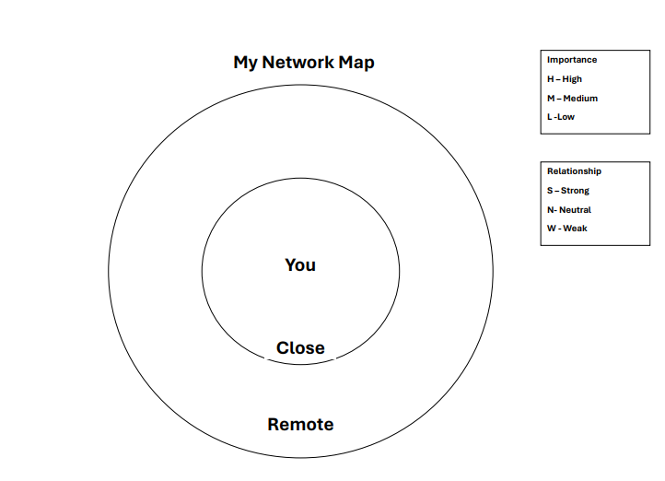

Stakeholder | Importance (Choose High, Medium, or Low) | Relationship (Choose Strong, Neutral, or Weak)

Module 1 wrap-up

Key learnings
Note your key learnings from this module below.

What’s next?
Use this reflection space to identify 1 or 2 key actions you will implement from this module.

Manager feedback (optional)
Discuss your reflections with your manager or another trusted mentor. Use this reflection space to note down their feedback and advice for effectively implementing your new skills.

Module 2: Developing Others

Content summary

Leadership Insights
- Video: Leadership Insights from David Coomber, Lluwannee George and Prof. Heiko Spallek | 5 mins
Discover your own strengths
- Questionnaire: Values in Action Strengths Survey | 20 mins
- Reflection Activity: Strengths  - Optional academic resources | 20 mins
Leading With a Growth Mindset
- Videos: Leading with a growth mindset | 40 mins
- Optional Academic Resources
Creating Psychological Safety
- Videos: How to collaborate with your colleagues to build psychological safety together | 25 mins
- Knowledge Check  - Reflection Activity: Growth Mindset and Psychological Safety  - Optional Academic resources | 5 mins  15 mins
Coaching and the GROW Model
- Reading: Coaching Defined and Explored | 30 mins
- Video GROW coaching framework | 20 mins
- Optional AI Coaching Tool and Academic resources
Giving Quality Feedback
- Podcast The psychology of feedback | 15 mins
- Reflection Activity: Feedback | 15 mins
Total:3 hours, 30 mins

Reflection activities
The following reflection activities are taken from the Workday Learning online modules. They are duplicated below to provide you with a space to record your learning.

2.2 Strengths

Think about your top strengths. How do these qualities support you in your work? How could you use them as a leader in the future?

Strength | Description | How have I used this in my work? | How could I use this as a leader?

2.3 Growth mindset and psychological safety

Answer the following questions to review and reflect on your learning.

1. What is a growth mindset? How can this help you to support others?

2. What is psychological safety? How could you influence a team to improve this?

3. Have you worked in a team where you felt unsafe to speak up? What was that experience like?

4. Have you worked in a team where the leader demonstrated a growth mindset? What was this experience like?

5. Have you ever worked with a leader who demonstrated a fixed mindset? How did this experience make you feel and how did it impact the work you did?

2.6 Feedback

After listening to the podcast, reflect on your learning and answer the questions below.

1. Think about a time when you received positive feedback. How did this feel? How did it help you to grow?

2. Think about a time when you received negative feedback. How did this feel? What was the result?

3. What key insights did you gain from the reading and podcast? How have you observed leaders using or not using these ideas?

Module 2 wrap-up

Key learnings
Note your key learnings from this module below.

What’s next?
Use this reflection space to identify 1 or 2 key actions you will implement from this module.

Manager feedback (optional)
Discuss your reflections with your manager or another trusted mentor. Use this reflection space to note down their feedback and advice for effectively implementing your new skills.

Module 3: Creative Problem Solving

Content summary

Leadership Insights
- Video: Leadership Insights from Olivia Perks, Nisha Padmanabhan and Prof. Heiko Spallek | 5 mins
Problem Solving
- Videos: Problem Solving Across an Organisation | 35 mins
- Reflection Activity: Problem Solving | 20 mins
- Optional Academic Resources
Decision Making
- Video: Cultivating Solution-Oriented Thinking  - Knowledge Check  - Reading: 5 Decision-Making Models To Try If You’re Stuck | 5 mins  10 mins
- Reflection Activity: Decision Making | 5 mins
- Optional Academic Resources
Finding Creative Solutions
- Videos: Take a More Creative Approach to Problem-Solving  - Video: Look Out For Group Think! | 30 mins  5 mins
- Knowledge Check: Matching Activity
- Reflection Activity: Finding Creative Solutions | 10 mins
Psychological Safety
- Podcast: Creating Psychological Safety in the Workplace  - Knowledge Check | 30 mins
Total:2 hours, 30 mins

Reflection activities
The following reflection activities are taken from the Workday Learning online modules. They are duplicated below to provide you with a space to record your learning.

3.2 Problem solving

After watching the videos in this course, reflect on the questions below and write your answers in the space provided.

Can you identify some areas in your current role that require problem solving? List them below.

Now select one problem from the above list and follow the steps from the learning module (listed below) to start identifying solutions.

Gaining Context

- Identify any cultural influences at play (e.g. mix of academic and professional staff):

- Identify the people and/or clientele who are impacted by this problem:

Defining the problem

- Identify the problem:

- Identify the players:

Creating Solutions

- Define your desired outcomes (i.e. what does success look like):

- Create a roadmap:

- Step 1.

- Step 2.

- Step 3.

[add as many steps as required. Note. Have you consulted with others about their view on these steps?]

- Evaluate your goals:

- Discuss alternative options and list them below:

Implementing Solutions

Reflect below on how you will gain buy-in prior to implementing your solutions, ensure transparent communication, and monitor progress to ensure outcomes are achieved.

3.3 Decision-making

Now that you have read about various decision-making models, map your problems from Part 1 to an appropriate decision-making model (use a minimum of 2 different models).

Problem Identified | Decision Making Model

Why not try to apply a decision-making model to one of your identified problems. What solutions did you come up with? List them below.

1.

2.

3.3 Creative solutions

Now that you have had a chance to hear about some creative approaches to problem
solving, how do you think you would change your solutions from the last reflection activity?

Original Solution | Amendments

Why not speak to your manager or colleagues to see how their approach might differ? Write your insights from these conversations below.

What are the key differences between their approach and yours?

Why is it important to consider a diverse range of perspectives when making decisions as a leader?

Module 3 wrap-up

Key learnings
Note your key learnings from this module below.

What’s next?
Use this reflection space to identify 1 or 2 key actions you will implement from this module.

Manager feedback (optional)
Discuss your reflections with your manager or another trusted mentor. Use this reflection space to note down their feedback and advice for effectively implementing your new skills.

Module 4: Navigating Change

Content summary

Leadership Insights
- Video: Leadership Insights from Dr Emma Bowen | 5 mins
- Optional Podcast: The future of higher education with Mark Scott | 40 mins
Cultivating an Adaptable Mindset
- LinkedIn Learning Course: How to be an adaptable employee during change and uncertainty | 35 mins
- Reflection Activity: Upcoming changes in your area of work | 15 mins
- Optional Reading: 6 tips for developing adaptability | 10 mins
Adaptive Leadership
- TedTalk: Introduction to adaptive leadership | 10 mins
- Knowledge Test: adaptive leadership mindsets and behaviours | 15 mins
Supporting Your Team Through Uncertainty
- Linked In Learning Course: Leading with stability during times of change and disruption | 35 mins
- Reflection Activity: Circle of control in your context | 20 mins
Overcoming Resistance to Change
- Video: SCARF Model Overview | 10 mins
- Reflection Activity: SCARF Model in your context | 20 mins
Total: 2 hours 45 minutes
Optional Learning: + 50 mins

Reflection activities

4.2 Upcoming changes in your area of work

Consider the types of changes you and your team are facing, or are likely to face in the future. You may find it helpful to think about this under the categories of people, process and technology.

People-related changes
Consider the people in your team and their key skills, knowledge and experience. Think about the people you and your team regularly interact with - e.g. students, colleagues, external industry partners.

Process-related changes
Consider the core tasks your team are responsible for. What processes do you currently follow to achieve these tasks, and how are they likely to change?

Technology-related changes
Consider the physical and digital technologies that your team uses. How are these likely to change over the next 3 months? What about in the next year? Or next 5 years?

4.4 Circle of control

One of the key determinants of thriving and fulfilment is retaining a sense of autonomy or control. Organisational change often disrupts our sense that we are in control, which can be a threat to our wellbeing. Completing this circle of control activity can be liberating, as it helps us to let go of the things we cannot control, reducing anxiety about the uncontrollable factors that dominate our work lives.

Before you get started
- List core stressors: Consider an upcoming change you are facing either at work or home. Write down stressors associated with the change on a piece of paper.
- Annotate the diagram. These represent the circles of concern, influence and control. If you struggle to access this diagram you can populate the table instead.
- Categorise: Place stressors in the appropriate circles according to whether you can control or influence outcomes.
- Evaluate: Look at where you have placed stressors. Compile some action points: how are you going to focus more closely on the things within your control?

Things I can control | Things I can influence | Things that are outside of my control

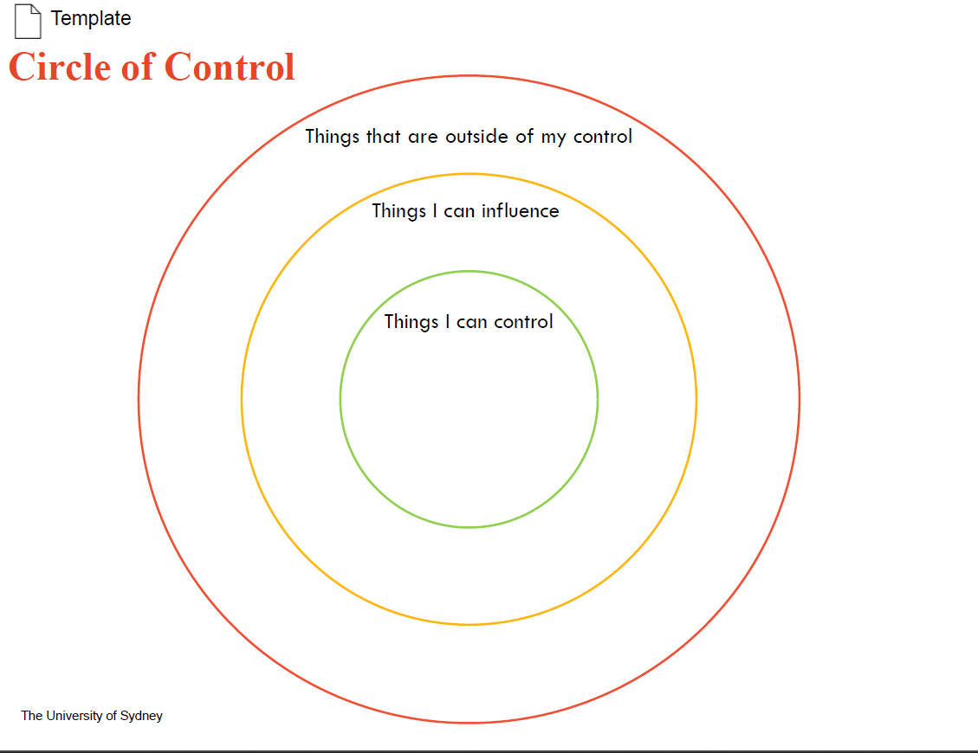

4.5 SCARF model reflection

According to David Rock’s SCARF model, there are 5 social domains that activate threat (or ‘fight or flight’) responses in our brain. Feeling threatened by change impedes our abilities to be creative, problem solve, communicate and collaborate. By minimising these threats from our position as leader, we can assist people to better cope with the difficult parts of change.

The table below gives some example responses following senior leadership announcing a ‘new strategic direction’ for the University. Whilst it’s been noted that the strategy will be ‘future focused’, and highlighted making better use of new technologies, it is currently unclear what this means at an operational level.

 | How might your team be threatened by change in terms of this domain? | What can you put in place to mitigate the threat response?
Status (our relative importance to others) | Assumptions about technology taking over people’s tasks or the threat of redundancies. | Reassure people of their value-add, consider how to highlight people’s strengths that are unique to them.
Certainty (our ability to predict the future) | Team worried about the unknowable power of technology and how it might change their role and the team. | Communicate as much as you are allowed to say about the change. Consider holding information sessions to learn about basics of AI, etc.
Autonomy (our sense of control over events) | People feel the change has been put upon them without consultation. Also may be some concerns around privacy and security with extra technology. | Consult team members throughout the change journey. Reassure them of how their data and digital footprint are being monitored.
Relatedness (our connection with others) | Technology uptake possibly reducing time spent face to face with colleagues and reducing water cooler chat. | Prioritise regular one-on-ones and face to face connection in a way that works for the team.
Fairness (how fair we perceive exchanges or systems to be) | Changes benefitting some more than others (e.g., those who are more technologically adept). | Ensure equitable training opportunities for those who feel they want to upskill in this space.

Think back to the changes you identified in section 4.2. Reflect on the possible threats and actions for your team below.

Consider whether you would like to share your responses with your team members and encourage a discussion around the change, or just use the outcomes of this activity to guide your own behaviours.

 | How might your team be threatened  by change in terms of this domain? | What can you put in place to mitigate  the threat response?
Status (our relative importance to others)
Certainty (our ability to predict the future)
Autonomy (our sense of control over events)
Relatedness (our connection with others)
Fairness (how fair we perceive exchanges or systems to be)

This activity is most effective when applied to one of the current or upcoming changes you identified earlier in this module. However, if you are struggling to think of a relevant situation, choose one of the following case studies to consider:

Case study 1

"As an Associate Lecturer in the Faculty of Science, I've noticed a drop in student engagement in one of the units of study I teach on. To address this, I proposed trialing a peer-assisted learning program where 2nd year students help 1st year students in study sessions and co-present at the end of semester.

Some of the 1st year students have shown reluctance to engage in this process (“Why are we changing things? I like things better the way they are”). I know many of them are not confident speaking in front of their peers. Additionally, our students come from diverse backgrounds, including international students who may struggle with language barriers and first-generation university students.

I understand that change can be daunting, but I believe this approach will foster a more interactive and supportive learning environment, ultimately benefiting the students' academic experience.”

Case study 2

“I am a new team leader in the Faculty's education support team. Our team has been using manual Microsoft Excel processes to track our student placements for years, which has led to inefficiencies and errors. To improve this, as part of my new role I’ve worked with the Senior Manager to implement a new student recruitment tracking system.

Most of our staff have been with the team for 10 years or more and were very comfortable with the old system. I’ve noticed that some of the team, particularly those with longer tenure, are not enthusiastic about this change – there have been comments in team meetings such as “another change?” and “I don’t have time to learn a new system, the way we do things is fine.” Hannah, who was acting team leader before I took on this role, is particularly vocal about her opposition.

Despite this reluctance, I strongly feel this will be more efficient and bring our team into the 21st century! ”

Module 4 wrap-up

Key learnings
Note your key learnings from this module below.

What’s next?
Use this reflection space to identify 1 or 2 key actions you will implement from this module.

Manager feedback (optional)
Discuss your reflections with your manager or another trusted mentor. Use this reflection space to note down their feedback and advice for effectively implementing your new skills.

Module 5: Demonstrating Accountability

Content summary

Leadership Insights
- Video: Leadership Insights from Nisha Padmanhaban | 5 mins
Personal Accountability
- Videos: Holding Yourself Accountable  - Article: Accountability Habits | 35 mins  5 mins
- Reflection activity: personal accountability | 15 mins
Leading Accountability
- Videos: Holding your team accountable | 50 mins
- Article: Being Responsive as a leader
- Video Being consistent and predictable in your messaging | 5 mins
Taking and Leading Initiative
- Video: Taking initiative on the right things  - Worksheet: Using the initiative quadrant tool | 5 mins  15 mins
Values and Value-Led Behaviours
- Article: What are your values | 5 mins
- Reflection activity: personal values | 20 mins
- Reading: University values | 5 mins
- Matching activity – University values  - Reflection activity: University values | 15 mins
Total: Approx 3 hours

Reflection activities
The following reflection activities are taken from the Workday Learning online modules. They are duplicated below to provide you with a space to record your learning.

5.2 Personal accountability

Answer the following questions to review and reflect on your learning.

What does accountability mean to you?

What accountability habits do you already have?

What new strategies could you implement?

How will being accountable help you succeed in your career?

5.4 The initiative quadrant

Use the template below to help you or a team member decide whether an initiative is appropriate. If you are unable to access this template you can use the table below.

When populating this, consider the following questions:

- Does the initiative align with the University strategy?
- Do I have personal interest and expertise to lead it?
- Do I have the capacity and resources to execute it?
- Do I have the authority to lead it?

High Reward

High Effort
Low Effort

Low Reward

Created based on Mautz, S. 2023, Taking Initiative on the Right Things (LinkedIn Learning Course)

High Reward/ Low Effort
High Reward/ High Effort
Low Reward/ Low Effort
Low Reward/ High Effort

5.5. Personal values
Refer to the article What are your values? and answer the following questions to determine your personal values.

Identify the times when you were happiest.

Identify the times when you were most proud.

Identify the times when you were most fulfilled and satisfied.

Determine your top values.

Prioritise your top 2 or 3 values

1.
2.
3.

Reaffirm your values

When do you notice yourself demonstrating these values? How do they help you make life decisions?

5.5. University values

After reading the values information, complete the table below with examples from your work team.

Value | Behaviours | I show this value at work by…. | An example I have witnessed at work is…
Accountability

Excellence

Trust

Module 5 wrap-up

Key learnings
Note your key learnings from this module below.

What’s next?
Use this reflection space to identify 1 or 2 key actions you will implement from this module.

Manager feedback (optional)
Discuss your reflections with your manager or another trusted mentor. Use this reflection space to note down their feedback and advice for effectively implementing your new skills.

Module 6: Working Effectively

Content summary

Leadership Insights
- Video: Leadership Insights from Olivia Perks | 5 mins
Your Personal Productivity Style
- Video: Introducing personal productivity styles | 5 mins
- Interactive Assessment: What’s your productivity style? | 10 mins
- Videos: Explore your productivity style & Manage across productivity styles | 10 mins
Prioritising Between Competing Demands
- LinkedIn Learning Course: How to set goals when everything feels like a priority | 15 mins
- Video: What’s a priority- and what’s not? | 5 mins
- Reflection Activity: Prioritsation matrix | 20 mins
Time Management Takeaways
- 2 x Time Management Takeaway videos (self-selected) | 10 mins
Optimising Workflow and Team Effectiveness
- LinkedIn Learning Course: Building your team | 55 mins
- Knowledge Test: Norming, Forming, Storming, Performing | 5 mins
- Reflection Activity: Enhancing Team Effectiveness | 25 mins
Total: 2 hours 45 minutes

Reflection activities
The following reflection activities are taken from the Workday Learning online modules. They are duplicated below to provide you with a space to record your learning.

6.3 Prioritise between competing demands

If you are an existing people leader, you can complete this matrix with your team's workload in mind. If you are not yet a people leader, focus on your own competing tasks and use this matrix to get a better understanding of where you should prioritise your focus.

 | Urgent | Not Urgent
Important
Not important

6.4 Time management takeaways

What are your 2 meaningful actions you will start implementing this week?

1.

2.

6.5 Reflection activity: Enhancing team effectiveness

After participating in the Building your Team LinkedIn Learning course, consider your own team. If you are a people leader, this should be the team that you lead. If you are not yet a people leader, consider a team you are a member of – e.g. a research project team, a professional services team, or a teaching team.

i. What stage of team development do you think you are in? – Highlight 1 of the below.

- Forming
- Storming
- Norming
- Performing

ii. What do you see as the 2 main challenges and 2 main opportunities of being in this stage of team development?

Challenges | Opportunities
1.  2. | 1.  2.

iii. How effectively is your team working together?
Determine how true each of the below statements is for your team. Once you have identified areas for improvement, identify actions you will take to improve your team’s effectiveness.
Some ideas have been included in the final column to support your thinking. You may also want to revisit section 4 and 5 of the video course for further ideas.
Statement | Rate from 1 – 5,  (1 = strongly disagree, 5 = strongly agree) | Action | Example Actions
My team has a clear purpose statement that is understood by all team members |  |  | - Run a session with your team to define your purpose statement.  - Discuss your team’s purpose statement with your supervisor or project lead during your next 121.
My team regularly evaluate our projects/workflow to identify lessons learned |  |  | - Try out one of these 5 team retrospective activities.  - Identify one idea that could have made your team more effective and share with your manager for feedback.
All our team meetings have a clear purpose and agenda |  |  | - I will draft a brief agenda for our next team meeting, asking team members for input.
We leave team meetings with a clear sense of actions and next steps |  |  | - I’ll ask for a volunteer to recap on actions at the end of the meeting.
My team can disagree well and reach consensus even when we have diverse views |  |  | - I will complete module 3 of the Foundational Leadership program, which focusses on creative problem solving and avoiding group think.

Module 6 wrap-up

Key learnings
Note your key learnings from this module below.

What’s next?
Use this reflection space to identify 1 or 2 key actions you will implement from this module.

Manager feedback (optional)
Discuss your reflections with your manager or another trusted mentor. Use this reflection space to note down their feedback and advice for effectively implementing your new skills.

Congratulations!
Best wishes for your leadership journey!

Revisit the hopes you identified in the introductory module and share your personal reflections below. What have you learned over this program? And how do you intend to put your new leadership skills into practice?

